Justin Cray

03/20/18

AMRUPT, SP 18

**Goals**

Due to my attendance at a conference this week, my goal was simply to update the report to reflect on our conversation we had with Dr. Kan and modify the report to include the SDR architecture.

**Problem**

Much of the architecture we’ve developed thus far has been implemented for the CC1310. In the attached I’ve modified the architecture description to reflect this.

**General Approach**

To do this, I went line by line through my assigned section of the report, the technical approach, and replaced all of the CC1310 architecture.

**Code-level problems and solutions, and empirical testing**

None

**Planned Course of Action**

I will likely have to complete larger portions of the report. We’ll see how the report discussion moves forward this week.

**Resources and relevant Forum Posts**

See the citations in the report. A lot of the report is based on the previous version.

**IV. Technical Approach**

The entirety of the proposed direction finding system consists of radio transmitters and receivers. This section will focus primarily on receiver design as the lightweight radio tags are being developed by another party. In order to achieve our design objectives, the receiver architecture will require the most development.

**I. Receiver Architecture**

We first propose a receiver architecture that consists of an RTL SDR to simplify wireless communication and improve the cost effectiveness of this project. The receiver architecture is outlined in Figure 1. Note that this now includes 4 antennas to complete Watson-Watt Angle of Arrival (AoA) measurements. Also note the decided clock board with highly stable (0.1 ppm) TCXO. This board must also have the power to drive multiple SDRs.

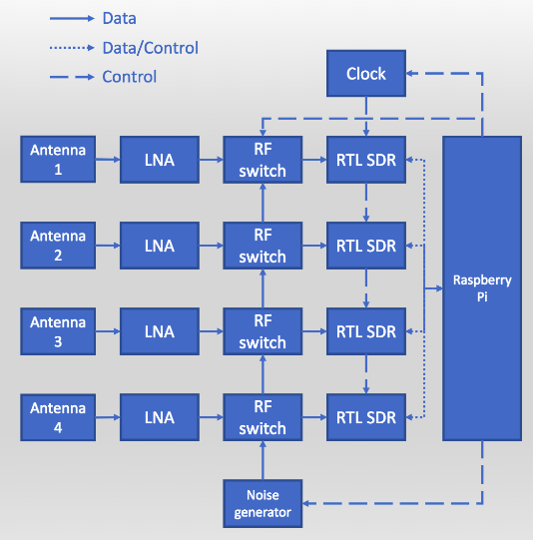

Figure 1: Receiver Architecture [1]

The ideal embedded device would include the following:

1. A sub 1-GHz device for VHF or UHF frequencies transmitted from radio tags. We choose a lower frequency band (relative to most RF applications) to mitigate multipath interference and better determine the phase difference of signals. Previous systems have used ~150 MHz as the operating frequency of transmitters because of the impact of large trees on multipath interference.
2. A very high sample frequency during the analog to digital conversion of RF signals. This is essential for mitigating adverse effect from noise when determining accurate phase differences from radio waves moving at the speed of light. However, a sampling frequency above twice the radio frequency (constant in a non-frequency modulated signals) is not needed. Sampling rates are further discussed in section IV. Vii. “RF Wave Reconstruction and Matlab Simulation”.
3. Ample UART/I2C/SPI/GPIO connections for data logging and transfer
4. Contains every component necessary for receiving an RF signal from an external antenna – ADC, local oscillator, etc.
5. Extremely high RF sensitivity and blocking performance
6. Programmable and highly used by the public – helpful for finding more tutorials and readily available information on the device
7. Low power and low cost

From this list of specifications, the RTL SDR was chosen. The RTL SDR specifications are outlined in [2]. To address the above, the following specifications are highlighted. The maximum sample rate that does not drop samples is 2.4 MS/s. The RTL SDR uses USB to interface directly with the Raspberry Pi. The frequency range depends on the dongles used. While we have not decided which dongle we will use yet, some options are outlined in Table 1 [3].

|  |  |
| --- | --- |
| **Tuner** | **Frequency range** |
| Elonics E4000 | 52 – 2200 MHz with a gap from 1100 MHz to 1250 MHz (varies) |
| Rafael Micro R820T | 24 – 1766 MHz |
| Rafael Micro R828D | 24 – 1766 MHz |
| Fitipower FC0013 | 22 – 1100 MHz (FC0013B/C, FC0013G has a separate L-band input, which is unconnected on most sticks) |
| Fitipower FC0012 | 22 – 948.6 MHz |
| FCI FC2580 | 146 – 308 MHz and 438 – 924 MHz (gap in between) |

Table 1: RTL SDR Frequency Ranges

**II. Antennas**

We seek an antenna that is in our target frequency range (the VHF band) and also has an SMA for ease of interfacing with the SDR dongle. To accomplish this, an antenna such as the ANT700 is compact high gain antenna and operates in the expected frequency range.

**III. RF Switch**

An RF switch board will be created for this project. Leveraging a high isolation and low insertion loss RF switch such as the ADG918 we can switch between two antennas mounted on a PCB. The isolation and insertion loss parameters are dependent on the Raspberry Pi and other external hardware. To derive these numbers, mock RF signals will be inserted through the system to measure the system’s loss. The ADG918 will operate in the UHF range making it a practical candidate for the project. The ADG918 will be controlled by the Raspberry Pi. By sending GPIO signals the Pi can toggle the ADG918 between the RF signal and the RF noise. This is done in order to calibrate the system for initial phase offsets due to program execution differences. Many mounts and cables are available for these connections allowing us to connect the antenna to the RF switch to the RTL-SDR by using commercially available adapters.

**IV. I/Q Extraction**

Since an RF wave can be essentially modeled as a sinusoidal function, the instantaneous phase, or the wave’s offset from its origin (universally recognized as f(x) = 0, f’(x) > 0) can be more effectively determined by using the signal’s real (I: In-phase) and imaginary (Q: Quadrature) components (Guerin, Jackson, Kelly 2012).

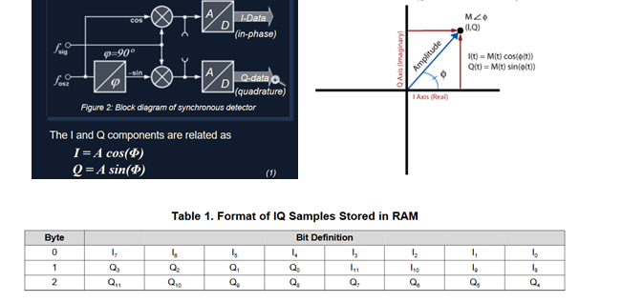

Figure 5: A radio frequency signal can be decomposed into a real and imaginary value top-right. The in phase and quadrature information can be obtained from the top-left setup through an I/Q Demodulator (The RTL-SDR employs a similar I/Q demodulation within its circuitry).

If the I/Q data of an RF signal is received from two antennas in real time, the phase difference between these two signals can be determined by the following calculations:

Phase angle between Signal 1 (ph2) =atan(Q/I)

Phase angle between Signal 2 (ph1) =atan(Q/I)

Phase difference = ph1-ph2

[1]https://github.com/jakapoor/AMRUPT/blob/master/Course%20materials%20and%20assignments/Weekly%20meetings/2018_Spring/Week_7_(03-16-18)/DF_week_7_03_16_18.pdf

[2] https://www.rtl-sdr.com/about-rtl-sdr/

[3] <https://osmocom.org/projects/sdr/wiki/rtl-sdr>